

**B S MEMORIAL HIGH SCHOOL BALUMATH**

**...*Always Ahead***

**U-DISE Code: 20220715108**

**A Co-Educational English Medium School**

**From Class I to VIII**

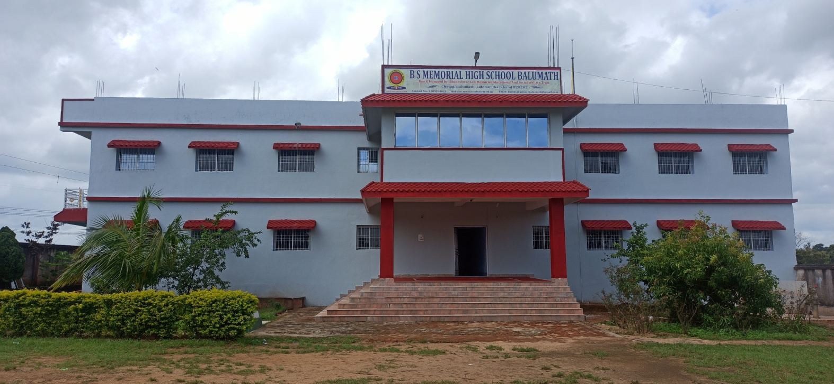**P R O S P E C T U S**

**Run & Managed By**

**Bhuneshwar Saw Memorial Educational And Social Welfare Trust**

**Chetag, Balumath, Latehar, Jharkhand 829202**

**Contact No.: 6205280821, 9334168726**

**Email:** [**bsmhighschoolbalumath@gmail.com**](mailto:bsmhighschoolbalumath@gmail.com)

**Website:** [**www.bsmbalumath.in**](http://www.bsmbalumath.in)

**The School: An Introduction**

**B S Memorial High School Balumath is an ideal educational institution. The School is dedicated to provide quality education based on human values. The School has modern facilities for children like Computer Lab., Science Laboratory, Digital Classroom, Library and many more. It provides a happy caring and stimulating environment where children recognize and achieve their full potential, so that they can make their best contributions to the society. Children are encouraged to become responsible and self-reliant and are taught to assimilate the larger communities which they belong to.**

**Through this school, a high standard of behavior is maintained and children are taught to give respect to their elders and to appreciate and regard the opinion of others. Thus, discipline plays a vital role in our institution. Since its establishment, the School has got the credit to build up strong foundation of many human brains in the society such as Engineer, Doctor, Teacher, Police Officer, Administrator, Social Worker, etc. All are working in various parts of the nation for its development.**

***“If we want to reach real peace in this world, we should start educating children.”***

***~ Mahatma Gandhi***

**From the Desk of Chairman**

**CHAIRMAN**

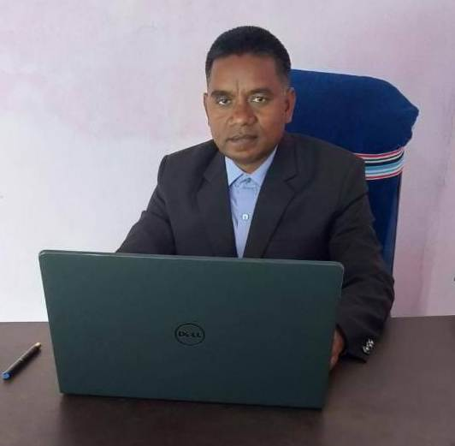

**ASHOK KUMAR**

Quality education provides a strong foundation to life of a human being, and it is truly said that Education is life. We all know that our society is facing many insurmountable problems today, like-alarming high growth rate of population, socio-economic and ethnological tensions, negligible mobility in poor segment of society, increasing disparities with diffusion of new technology. In such conditions, it is impossible to achieve the goal of growth with social justice; undoubtedly an egalitarian education can help to minimize the problem to ensure that all children of nation get proper education. Hence, Gurudev Ravindra Nath Tagore points out that The widest road to remove all existing problems is education.

Balumath is a large community development block of Latehar district of Jharkhand, but as per 2011 Census, only 58.22 percent of total population is literate .The condition of female literacy is more pitiable as it is only 38.69 percent of total population. As a parent, we want best for our children, many family moves to cities to provide best environment of education for their children but because of many existing circumstances like lack of money etc., a large part of society is not able to enjoy the educational facilities as that of cities. Keeping in mind the socio-economic conditions and need of quality education of this region we are working to provide affordable and quality education at grass-root level, so that the people of all segments can get the benefits of modern education for a better future.

Towards this goal, B S Memorial High School Balumath endeavors to provide diverse and highly skilled teachers, all essential educational facilities, tools and techniques and an ideal and effective teaching-learning environment where students will recognize their potentials and to prepare them for their life and country.

Ashok Kumar

**From the Manager’s Desk**

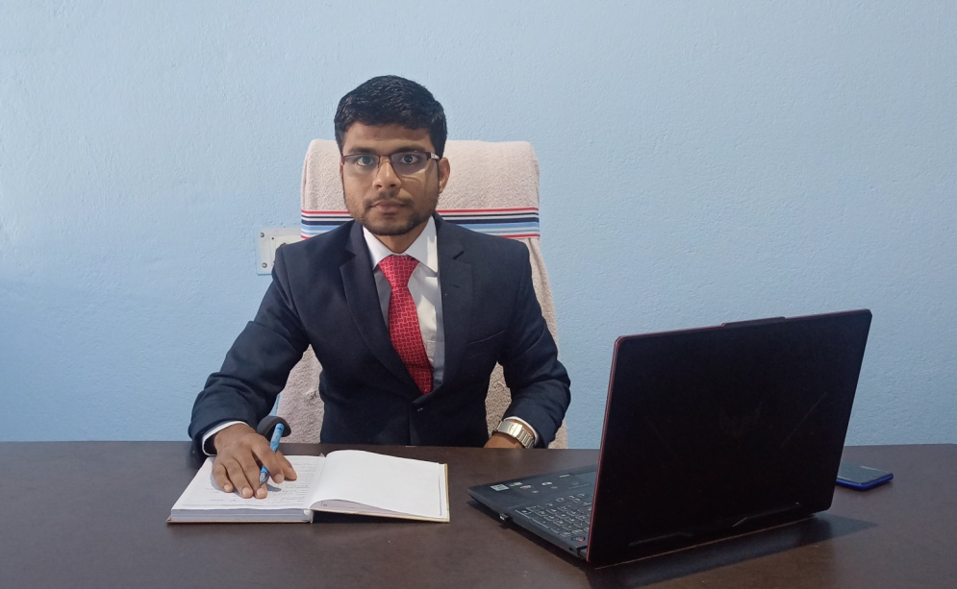

MANAGER

SHUBHAM KUMAR

We are a society, which is having a job-oriented tendency. This tendency seems to be unsustainable in our country at the time. We need entrepreneurial brains to maneuver with the pace of world and subsume the pressure of job demands. For all these, skills are required with good education. The preliminary understanding of this fact must be inculcated in students since their childhood.

B S Memorial High School Balumath is creating a congenial environment to instill the basic skills like communicative skills, writing skills, learning of computer and internet, games and sports, painting and so on. So that at any time in their lives, students can confidently decide for entrepreneurship and further excel. These will be helpful in passing through the difficult phases in their lives.

Along with quality education and basic skills, the other important factor in one’s life is moral values. In schools, we learn human values like friendship, cooperation, togetherness, justice, respect and so on. B S Memorial High school Balumath keeps all these in the reckoning and tries to shape students’ behavior with the inculcation of values in this highly aggressive and materialistic world.

Shubham Kumar

**Principal’s Message**

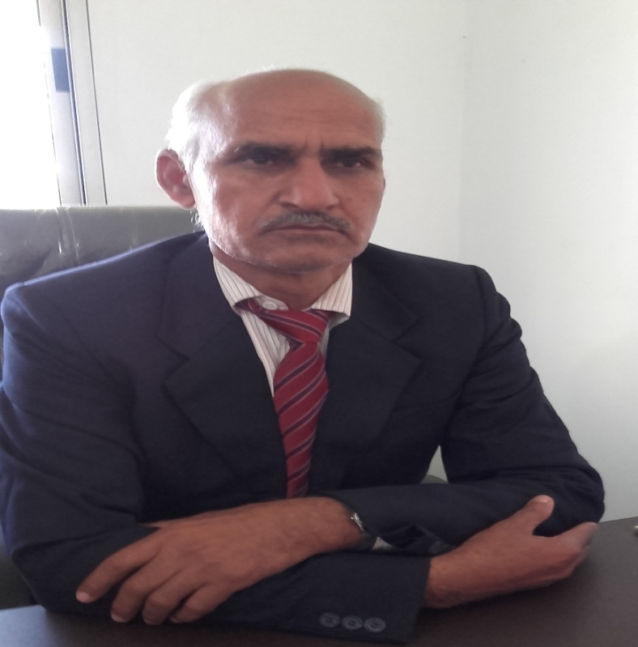

**JAGNARAYAN PATHAK**

**PRINCIPAL**

Children have always been our future. When we see exiting problems around us like – poverty, unemployment, hunger, homelessness, social-unrests, violence, women-exploitation, communalism, discrimination, terrorism, environmental degradation and many other tensions, solution stops at only point, that is – EDUCATION.

Education is not preparation for life, education is life itself, and the aim of education is to prepare the children to learn throughout their lives. The goal of preparing child for themselves and society as a whole can be achieved only through the spirit of togetherness among school, students, home, and society all four of these.

At B S Memorial High School Balumath, we create suitable environment for the all-round development of students on the basis of human values, so that they can make their best contributions to our society. In order to fulfill the demands of modern education, we provide a beautiful, peaceful and healthy campus, all basic amenities, effective teaching and learning process through highly skilled teachers and modern educational tools and techniques.

**Message to Parents**

In educating our children, the roles of school and home are complementary to each other. Therefore continuous guidance, support and co-operation to school and school family is very important, so we request the parents to spend some time with their children, talking not only about how they spent their day in the school but also their needs and problems they face.

Communication between teachers and parents is essential for children’s growth. Kindly attend Parent-Teacher Meetings regularly. It is important for parents to pay all fees on time for smooth functioning of the School.

Jagnarayan Pathak

**Aims & Objectives of the School**

* To prepare the students for their future with simple discipline.
* To inculcate in every student a spirit of excellence in academics as well as in co-curriculum activities.
* To inculcate in every student a high level of morality and integrity to lead a virtuous life.
* To instill in every student the sense of nationalism and brotherhood as well as respect for ‘Unity in Diversity’.
* To create a congenial environment for the development of physical, mental, social and spiritual aspects of human existence in every student.
* To instill confidence and positivity in students for their growth and to serve the nation in the best possible way.
* To create an environment where students can explore their inherent qualities and boost them for their bright future.

**Facilities of the School**

* Good Infrastructure ( Beautiful, Peaceful and Healthy Campus)
* Basic Facilities (Separate toilets for boys, girls and students with special abilities, safe drinking water, sanitation, electricity etc.)
* English Medium of Instruction
* Well Qualified and Specialized Teachers
* Library
* Science Laboratory
* Computer Lab.
* Maths Lab.
* Provision of Co-Curriculum Activities
* Games and Sports
* Digital Classroom (Smart-Class)

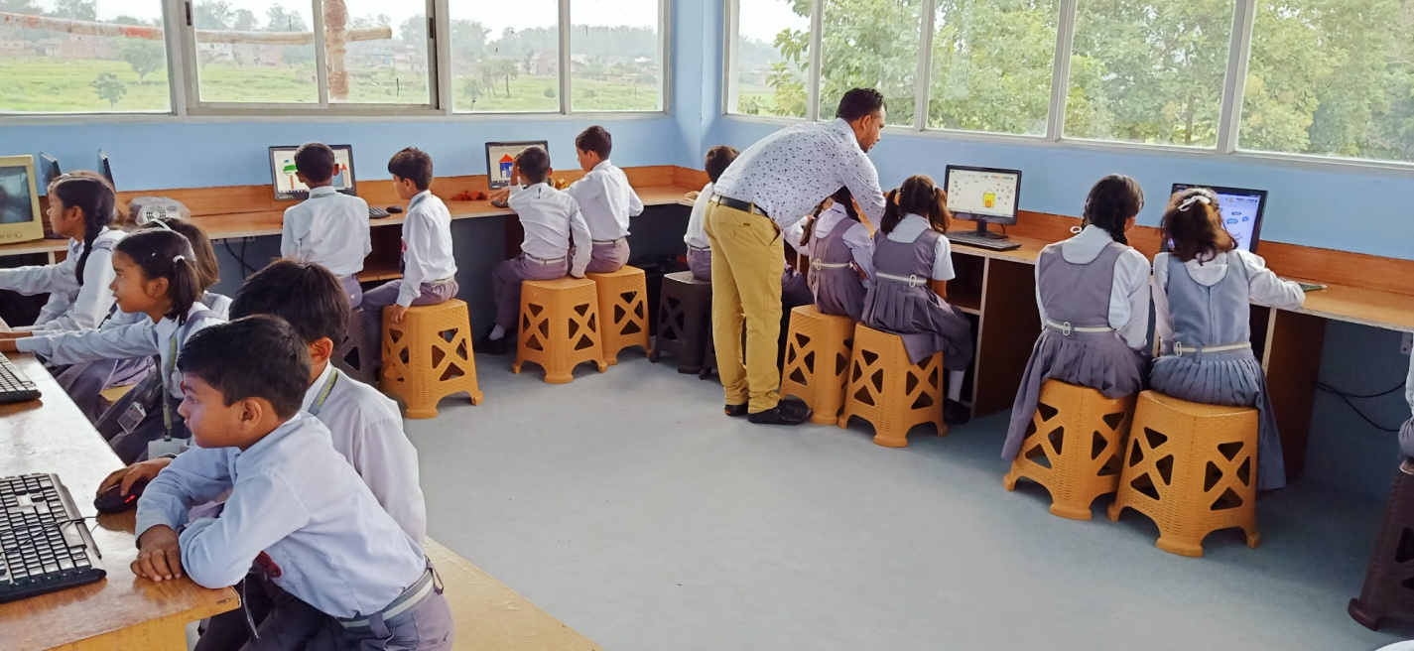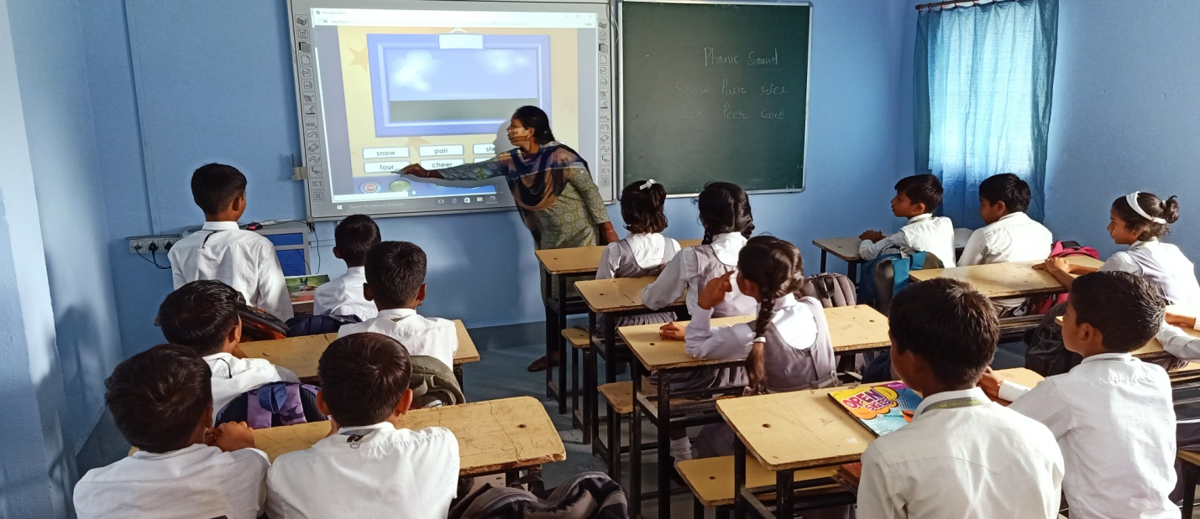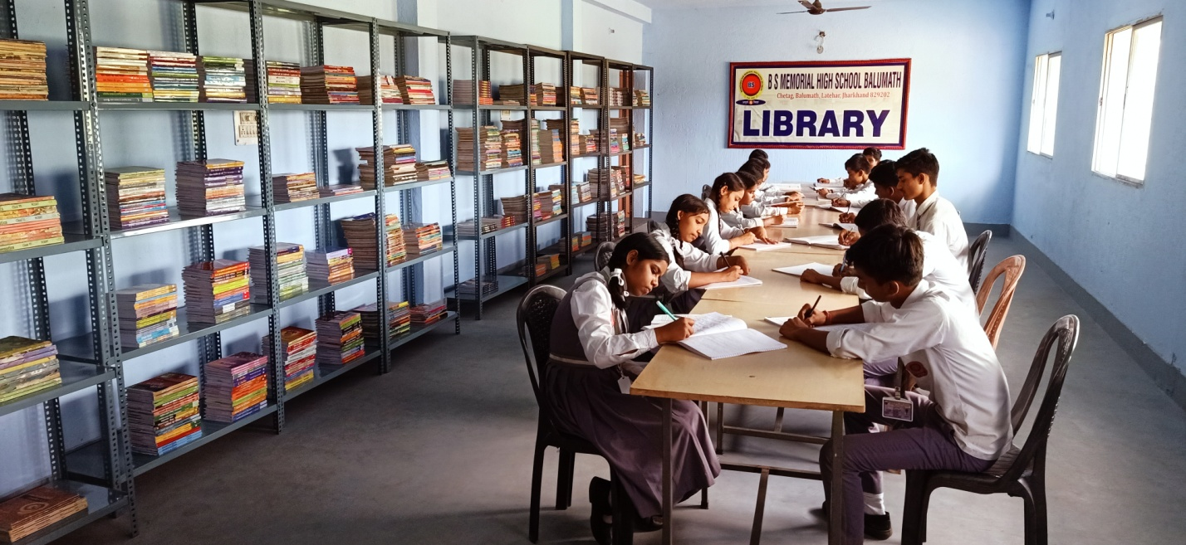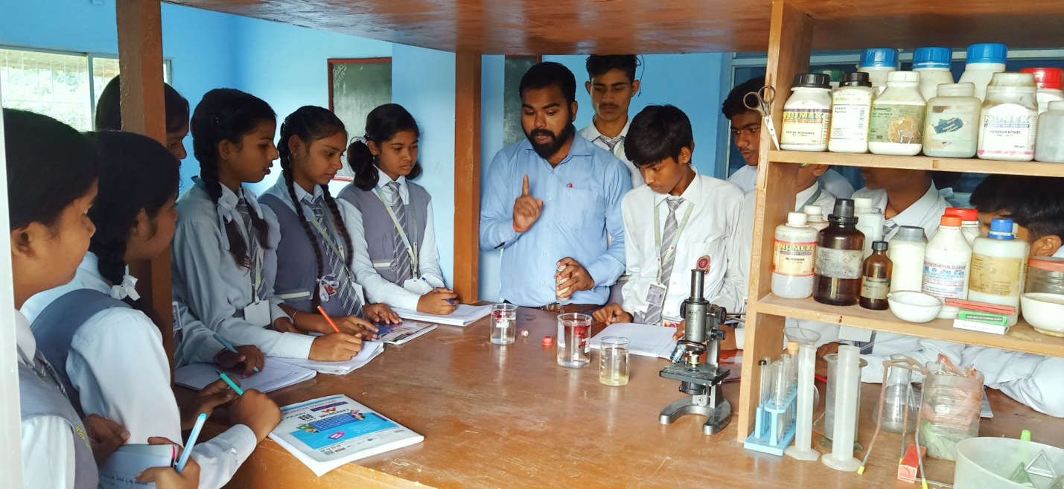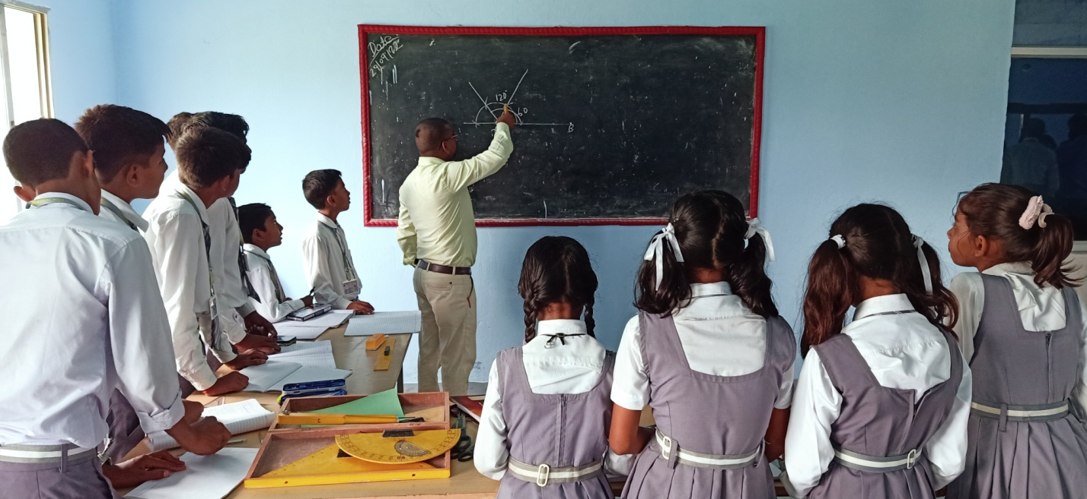

**Digital Classroom (Smart Class)**

**Computer Lab**

**Science Laboratory**

**Maths Lab.**

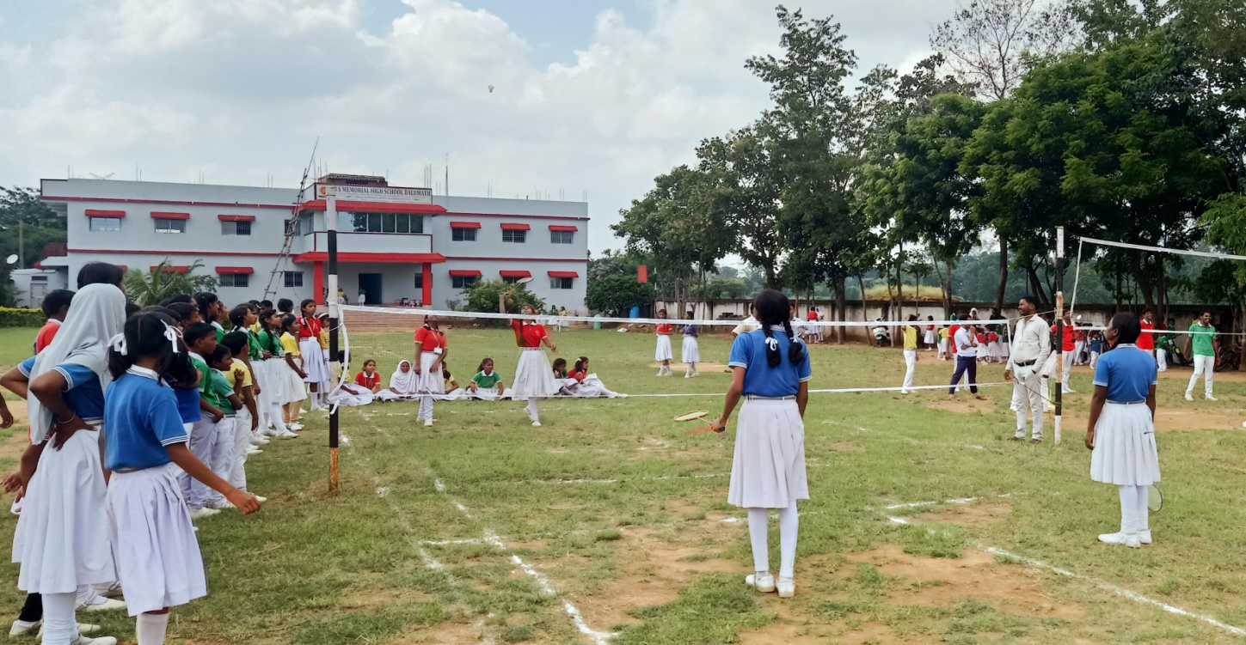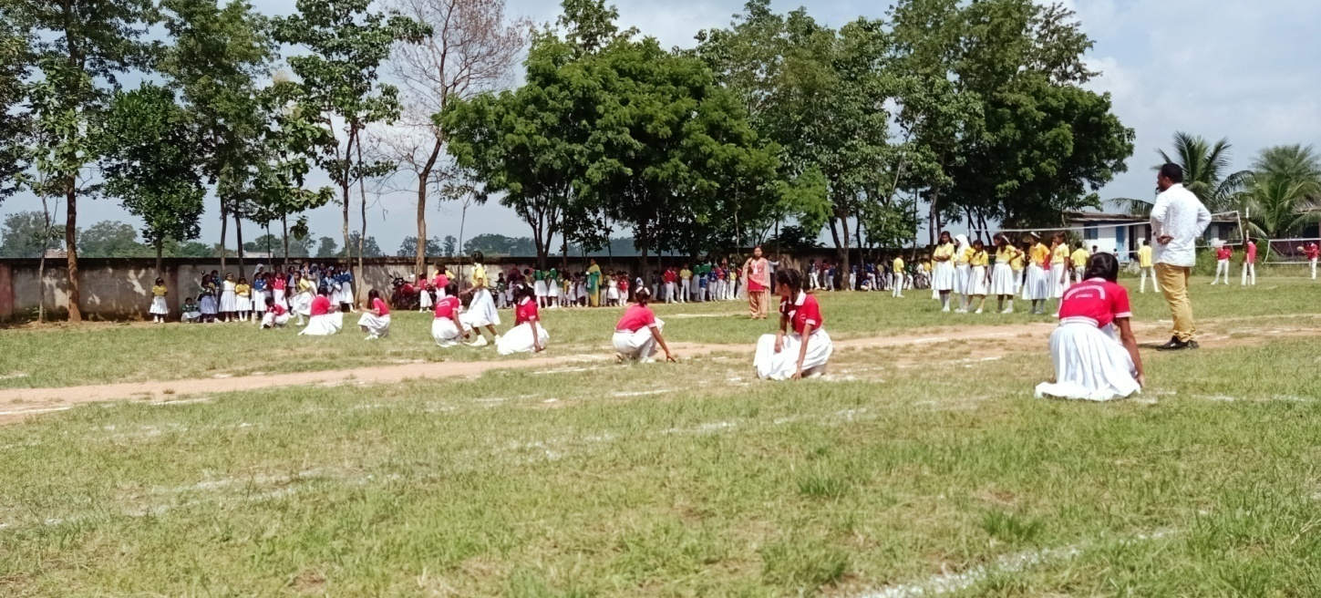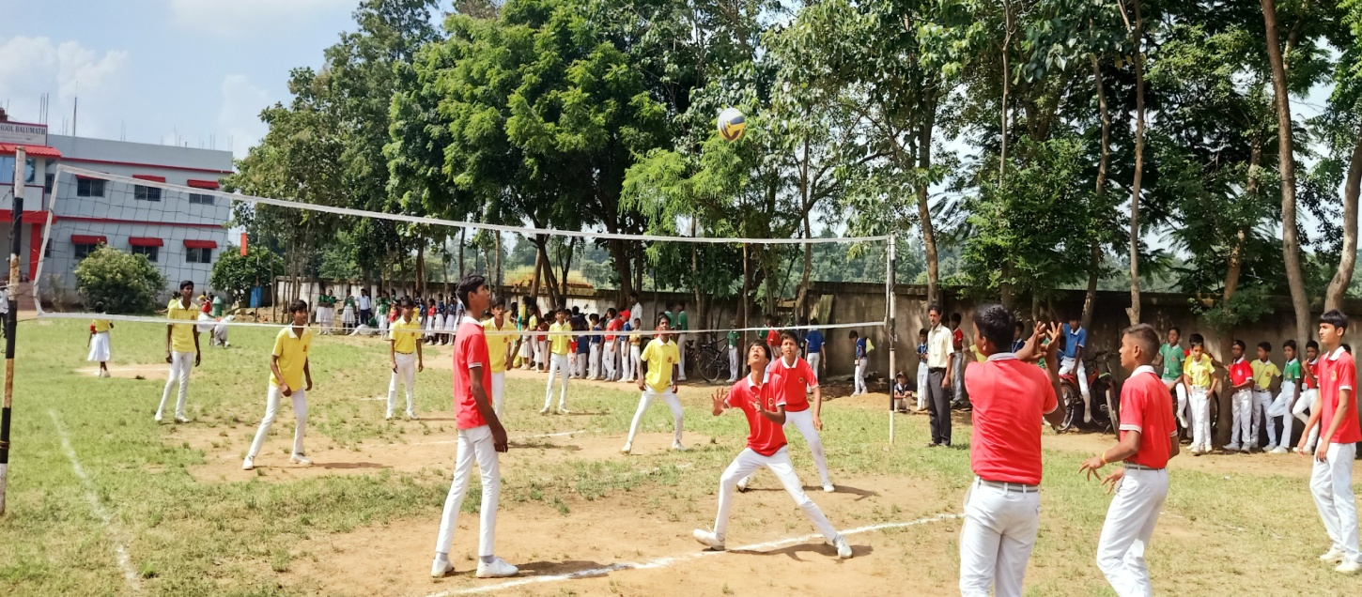

**Volleyball**

**Kho-Kho**

**Badminton**

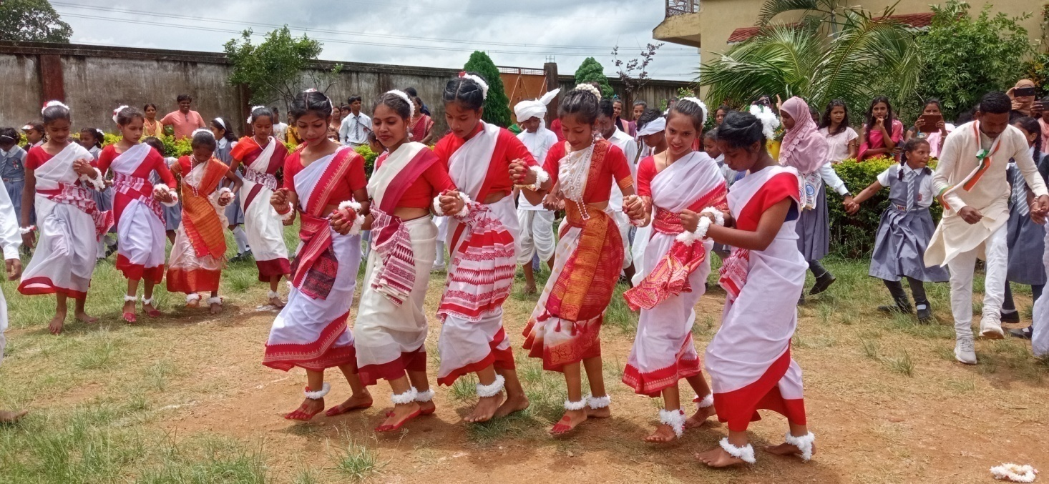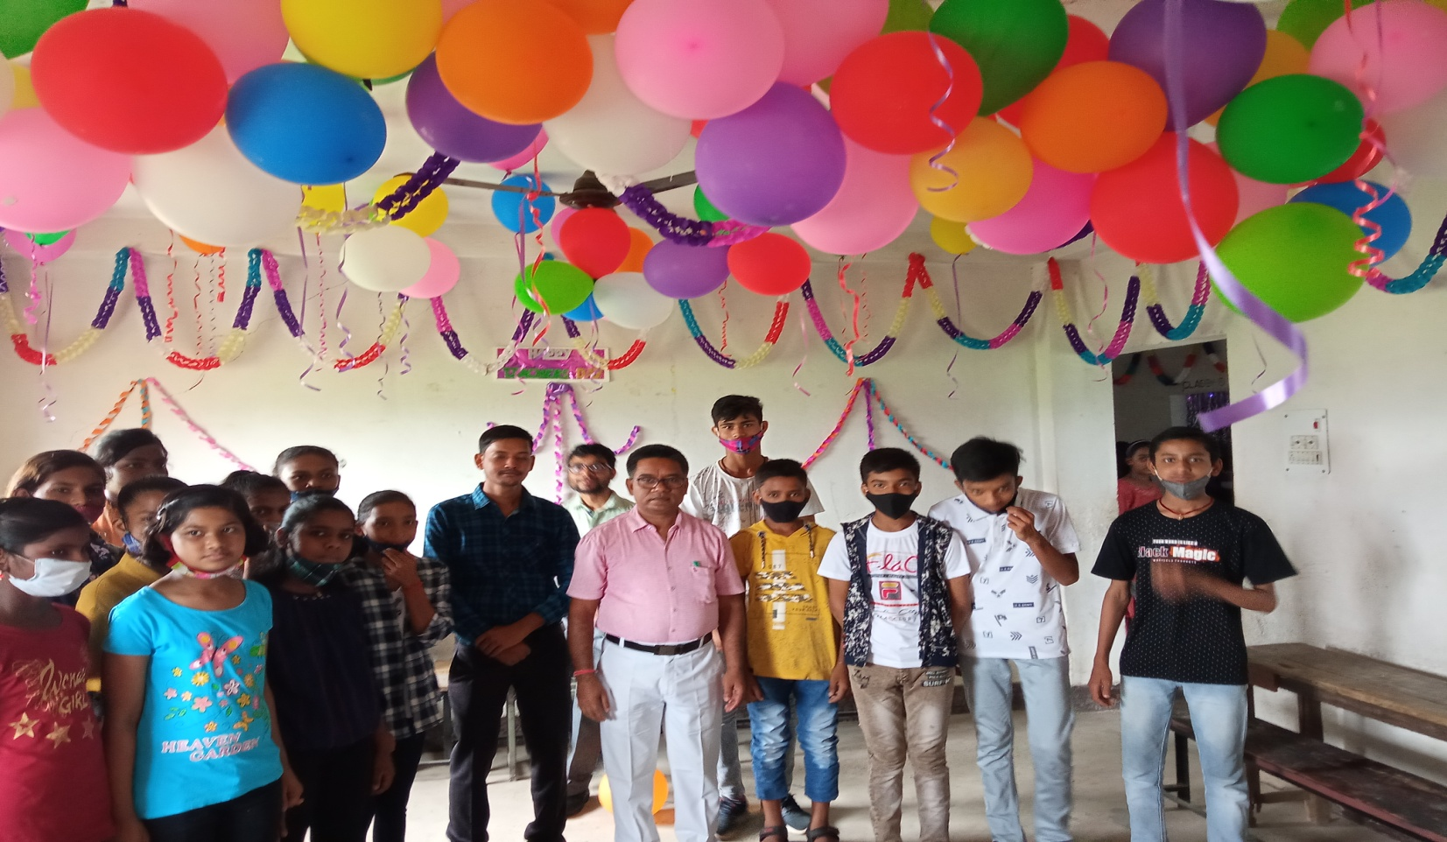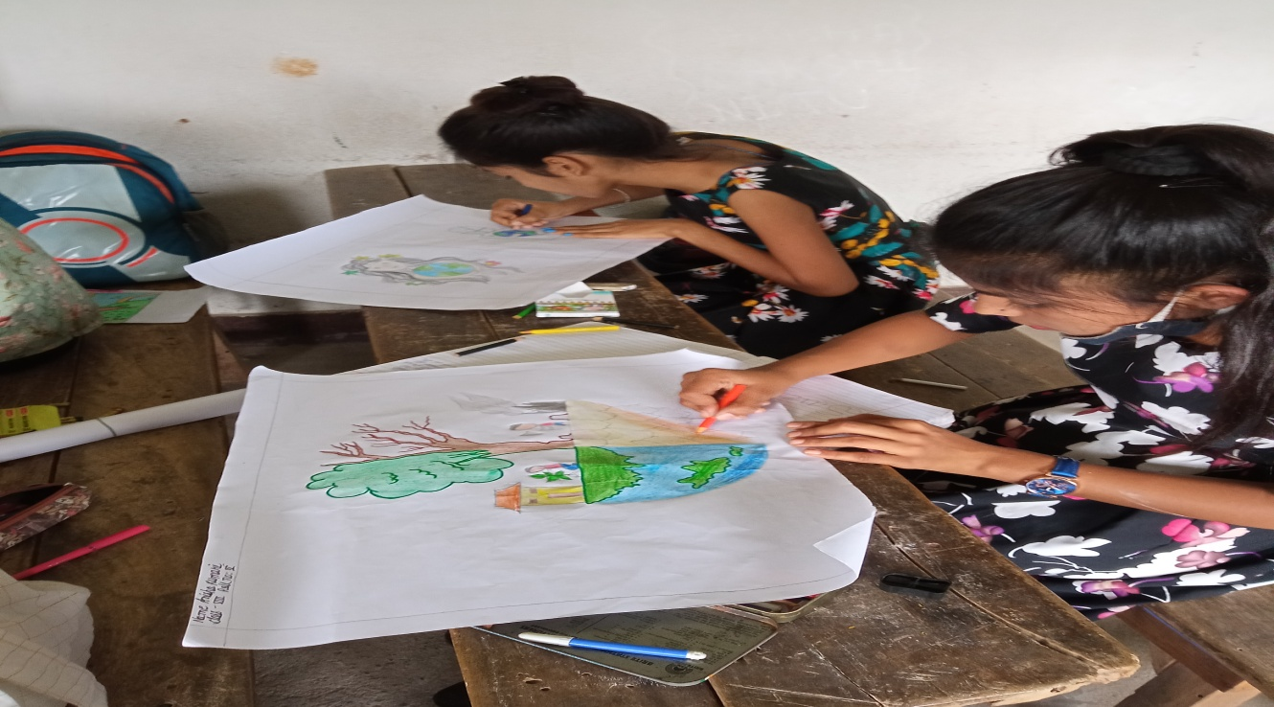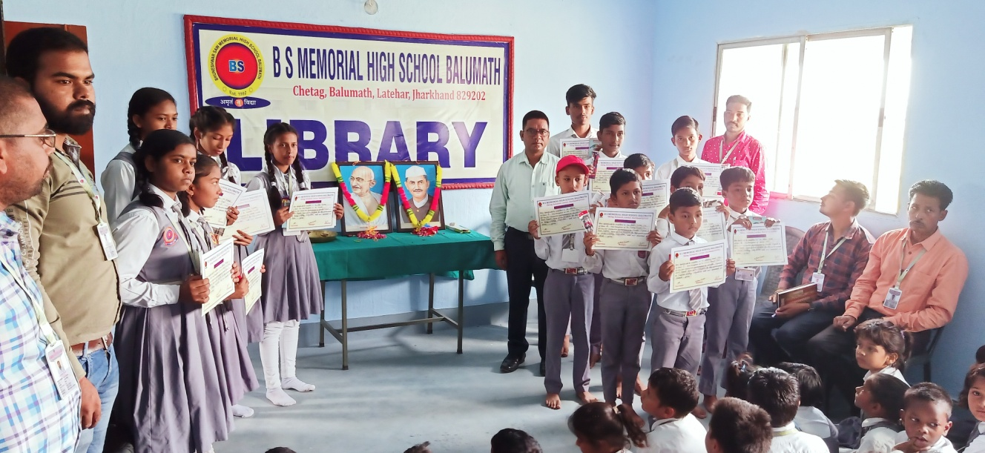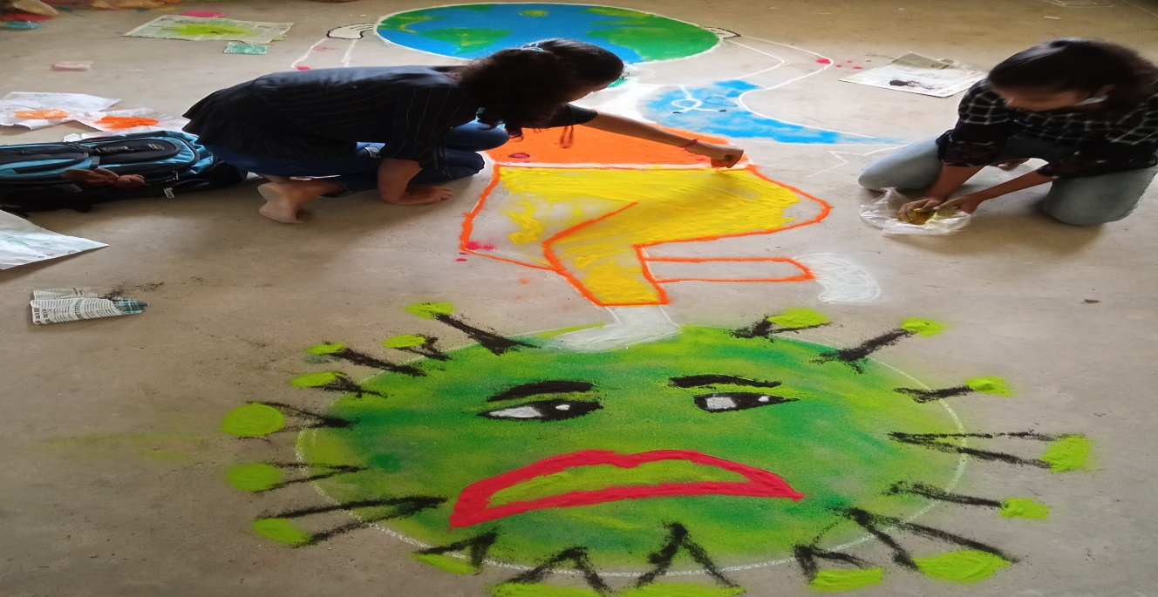

**Teachers’ Day Decoration**

**Cultural Dance**

**Drawing Competition**

**Certificate Distribution on Gandhi Jayanti**

**& Shastri jayanti**

**Making Rangoli**

**Rules and Regulations of the School:**

* Students must come to the school daily on time.
* Students are not allowed to remain absent without any reason and valid permission from the School.
* Unauthorized absence for more than 15 days will lead to removal of student’s name from the roll.
* Students need to produce recommended application by parents for any leave.
* Absence for more than three days just after a vacation renders the student liable to have his/her name struck-off from the roll.
* The students, who leave the school in between the session, will not be re-admitted.
* Students are not allowed to go out of the campus during the school hours including the recess time.
* Students are not allowed to wear any ornaments in the School.
* Students are not allowed to bring toys or mobile phone in the School.
* Every student needs to be present in the Assembly. So they should be present in the School atleast 5 minutes before the start of the Assembly.
* Silence should be observed since the assembly to the end of the School.
* Every student is a gentleman/gentle-lady by making. Hence, they should respect their teachers, parents, visitors and elders and show affection towards their youngers.
* Every student has to participate in all activities conducted by the School.
* Students have to come to school in full and proper School uniform, lest they will not be allowed to sit in the classroom.
* Irregularity, disobedience, theft, quarrelling, damaging school property, misconduct or malpractices during the examinations are the sufficient grounds for a student to be expelled from the School. No excuse will be entertained at any cost in these regards.
* Anything found in the School premises must be submitted to the school authorities as soon as possible.
* Students should complete their homework daily.
* Every student must have a school dairy for parent-teacher communication, complaints and advices.
* Every student must have separate notebooks of all subjects and must come with all study materials required for the day.
* Parents and relatives of any student are not allowed to enter into the classroom. They can meet the teachers only after due permission from the Principal.
* ‘Parents-Teachers Meeting’ is conducted twice in a year after the examinations.
* In case of necessity, a meeting may be conducted. Parents’ presence will be compulsory. Prior notice will be given for it.

**Payment of Fees**

* Tuition fees collection date is fixed from 1st to 10th day of a month. It is collected during the school hours.
* Late fine of Rs. 100/- will be charged with the fees of the month upto the 10th day of the next month.
* If the fee is not paid for two consecutive months, defaulter’s name will be struck off from the rolls.
* Re-admission of such students may be considered on payment of admission fee with the permission of the Principal.

**An Appeal to Parents**

* Parents are expected to co-operate with the School authorities in enforcing punctuality, regularity and discipline.
* Parents are expected for an active participation in all school activities by encouraging their children and helping them.
* Presence at Parents-Teachers Meeting will not only prove beneficial for their children but is also valued for the School.
* Parents are requested to check notebook, homework and School diary of their children daily. They must sign the School dairy daily.
* The School-dairy is a means of communication between parents and teachers. Parents can give their suggestions and complaints to teachers through the school dairy and in return, get the teachers’ responses.
* Parents are requested not to visit teachers’ residence.
* Parents are requested not to send their kids to School when they are ill (especially having any infectious diseases) and inform it in the School.

**Admission & Withdrawal:**

**Admission**

* Parents have to submit the duly filled Admission Form along with the fees of the particular Class.
* Once admission is taken, the fees paid shall not be refunded in any case.
* Parents need to submit the following documents of their Child at the time of admission:-
  + - 2 Coloured-Passport-sized photographs
    - Progress Report of the Previous school
    - Transfer Certificate
    - Birth Certificate
    - Aadhaar Card

**Withdrawal**

* Parents can give an application for withdrawal of their Child from the School.
* Before this, they will have to pay all the dues to the School.
* Then, they will be given the Transfer Certificate.

**Examination & Promotion**

|  |  |  |
| --- | --- | --- |
| **TERM - I** | | |
| **Sl. No.** | **Particulars of Exams** | **Marks** |
| 1.  2. | Periodic Assessment  Pen-Paper Test/Notebook Assessment/Subject Enrichment  Half yearly Exam | 20  80 |
| **TERM - II** | | |
| 3.  4. | Periodic Assessment  Pen-Paper Test/Notebook Assessment/Subject Enrichment  Annual Exam | 20  80 |

***Note:***

* Re-examination will not be conducted for absent students. So, presence of every student in the examination is compulsory.
* A student must score atleast 40 percent of marks to pass the exam and get promoted in the next class.

**School Timing**

|  |
| --- |
| Day Boarding (Winter Season) 08:30AM – 02:30PM |
| Morning Boarding (Summer Season) 07:00AM – 11:30AM |

*Note:* The School Timing may change according to the conditions.

**School Uniform**

|  |  |
| --- | --- |
| **REGULAR** | |
| **BOYS** | **GIRLS** |
| Shirt – White (Full Sleeve) | Shirt – White (Full Sleeve) |
| Trousers – Gray (Full) | Skirt – Gray |
| Shoes – Black | Shoes – Black |
| Socks – White | Socks – White |
| **ALTERNATE** | |
| **BOYS** | **GIRLS** |
| T-Shirt (According to House) | T-Shirt (According to House) |
| Trousers – White (Full) | Skirt – White |
| Shoes – White | Shoes – White |
| Socks – White | Socks – White |

**Photo Gallery**

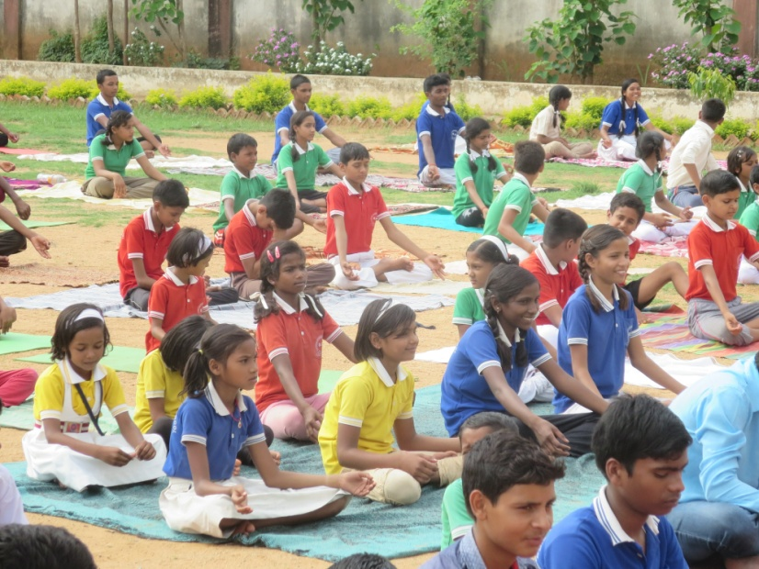 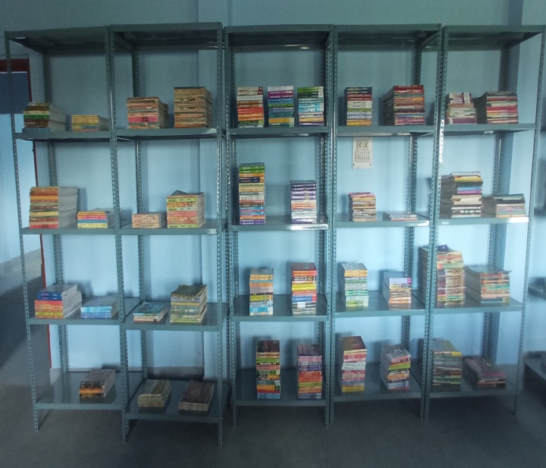

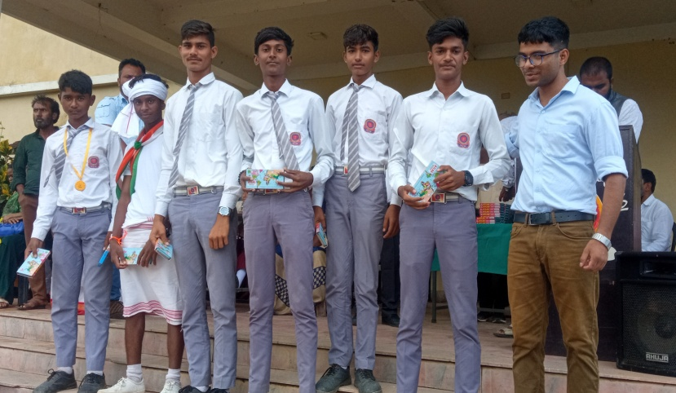 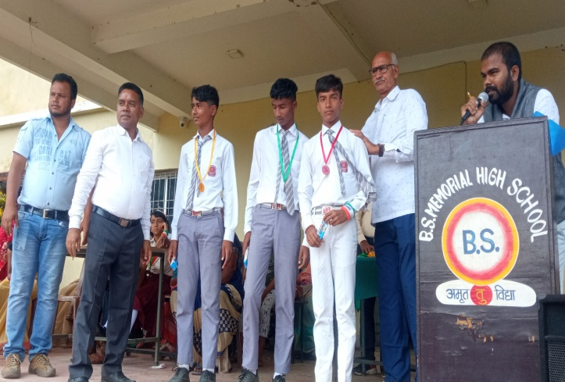

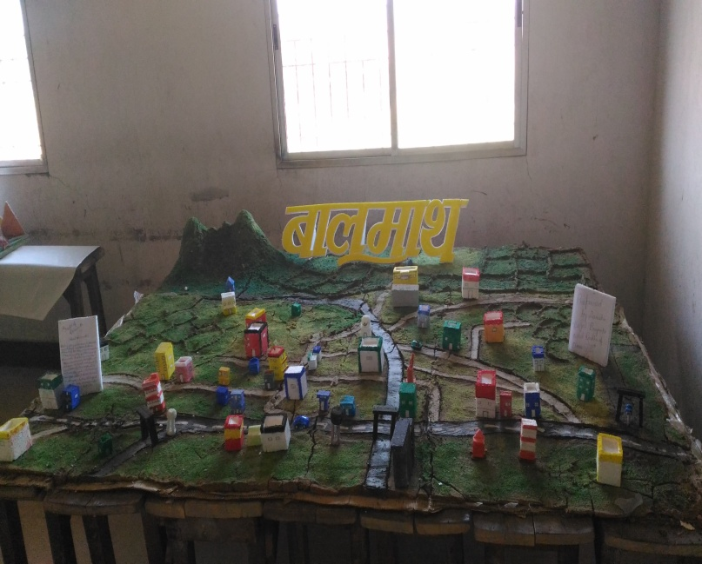 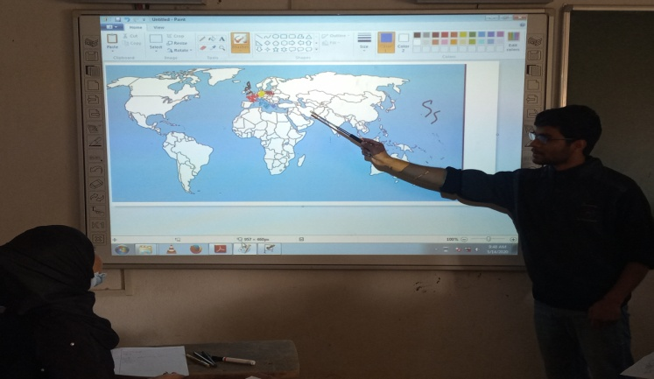

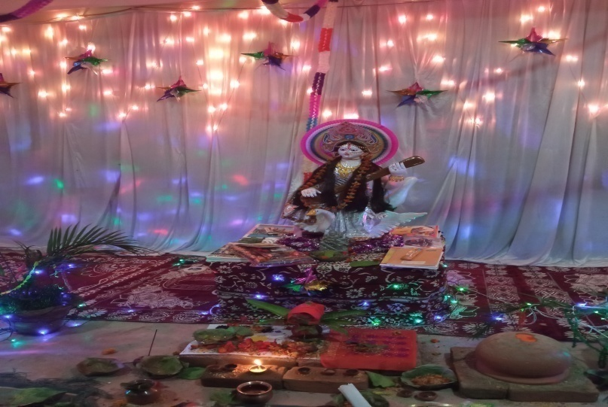 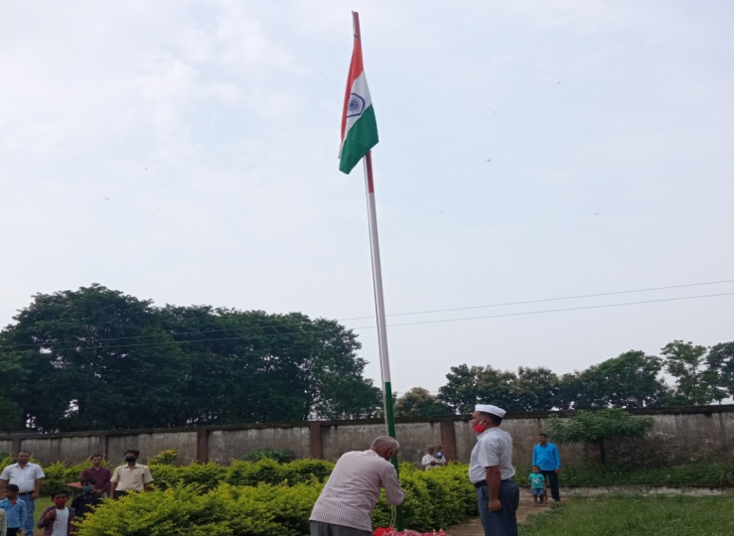

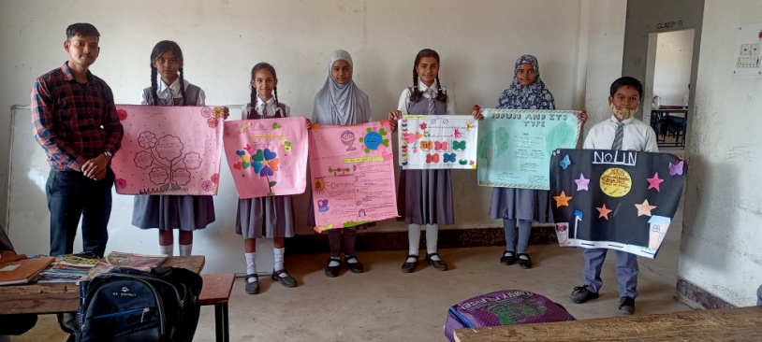 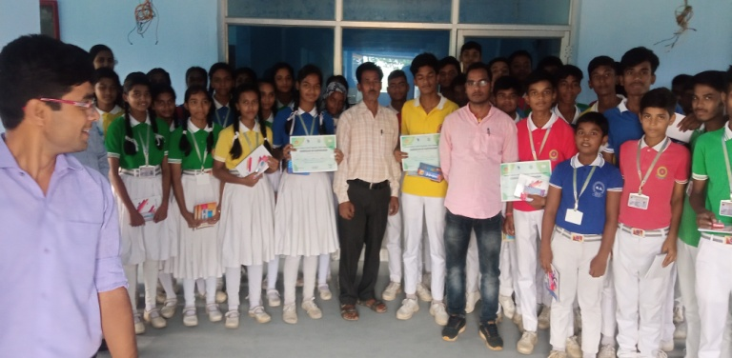

**Address for Correspondence**

**All communications shall be addressed to:**

**The Manager**

**B S MEMORIAL HIGH SCHOOL BALUMATH**

**Chetag, Balumath, Latehar, Jharkhand 829202**

**Contact No.: 6205280821, 9334168726**

**Email:** [**bsmhighschoolbalumath@gmail.com**](mailto:bsmhighschoolbalumath@gmail.com)

**Website:** [**www.bsmbalumath.in**](http://www.bsmbalumath.in)